THE UNIVERSITY OF AZAD JAMMU & KASHMIR, MUZAFFARABAD


COURSE TITLE | OS
COURSE CODE | CS-2105
LAB TITLE | WINDOWS CMD
STUDENT NAME | HASEEB SHEIKH
STUDENT ROLL NUMBER | 2024-SE-31
INSTRUCTOR NAME | ENGR. SIDRA RAFIQUE
SUBMISSION DATE | OCT 27, 2025

DEPARTMENT OF SOFTWARE ENGINEERING
OS
Lab 1
PART A
1. LOGOFF
- Syntax:
logoff
- Explanation
This command is used to sign out of the current Windows user session immediately from the Command Prompt. It's an alternative to using the graphical user interface for logging off.
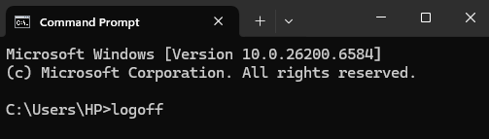
2. SHUTDOWN
- Syntax
shutdown /s
- Common Options:
- shutdown /s (Shuts down the computer.)
- shutdown /r (Restarts the computer.)
- shutdown /l (Logs off the current user.)
- shutdown /r /t [seconds] (Restarts after a specified time, e.g., shutdown /r /t 60 for 60 seconds.)
- Explanation
This versatile command is used to shutdown, restart, or log off the computer. The /s switch is used specifically to initiate a full shutdown of the system.

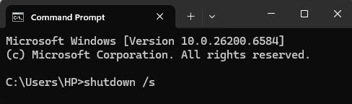

3. TASKLIST
- Syntax
tasklist
- Explanation
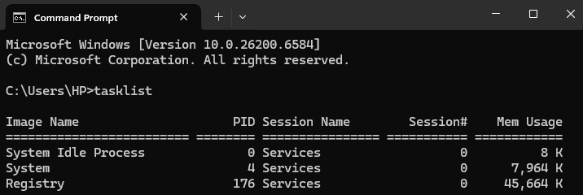
The command is used to display a list of all running processes on the local or a remote Windows computer, similar to the information found in the Windows Task Manager.

4. TASKKILL
- Syntax
taskkill /f /im [process name]
# OR
taskkill /f /pid [process ID]
- Explanation
This command is used to terminate (kill) a running process. You must first use the tasklist command to find the process name (e.g., chrome.exe) or its Process ID (PID). The /f switch is used to forcibly terminate the process.
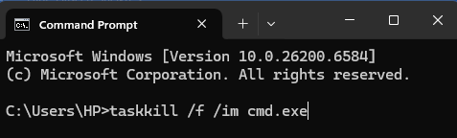

5. CHKDSK
- Syntax
chkdsk [drive letter]: /f
- Explanation
The chkdsk (Check Disk) command is used to check a drive for file system errors and bad sectors and attempt to repair them. It requires administrative privileges. The /f switch instructs the command to fix errors on the disk.
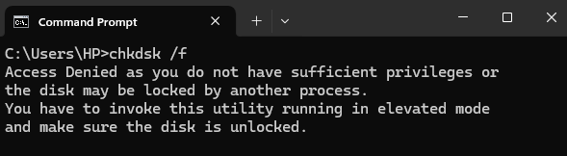

Note: I have not opened CMD as an Administrator that’s why access is denied.
6. SFC /SCANNOW
- Syntax
sfc /scannow
- Explanation
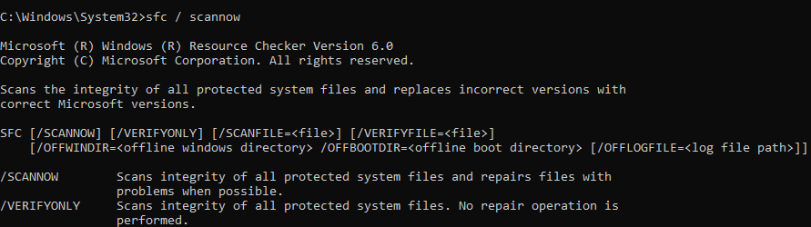
The sfc (System File Checker) command is a utility that scans and verifies the integrity of protected Windows system files and replaces incorrect, corrupted, changed, or missing versions with correct versions. The /scannow option initiates an immediate scan of all protected system files.

7. FORMAT
- Syntax
format [drive letter]: /fs:[file system] /q
- Example:
format e: /fs:ntfs /q
- Explanation
This command is used to format a drive (HDD, SSD, or USB), preparing it to store data by initializing its file system. You must specify the drive letter and the desired file system (e.g., NTFS or FAT32). The /q argument performs a quick format.
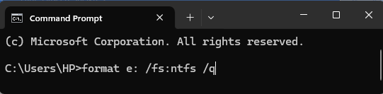

Note: I didn’t execute the command to avoid performing the format.
8. VER
- Syntax
ver
- Explanation
The ver command simply displays the version number and build of the Windows operating system currently running on the computer.
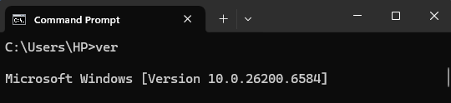

9. CLS (Clear Screen)
- Syntax
cls
- Explanation
The cls command, short for Clear Screen, is used to erase all previous commands and output from the Command Prompt window, providing a clean slate for the user to work from.
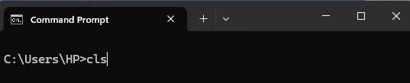

10. HELP
- Syntax
help
# OR
help [command]
- Explanation
The help command is an essential reference tool.
- Running just help displays a list of essential Command Prompt commands with brief descriptions.
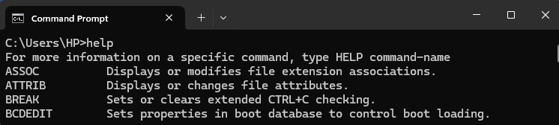
- Running help followed by a command name (e.g., help dir) displays the syntax, usage details, and a full description for that specific command.

Part B: Theoretical Questions

1. What is the purpose of the Command Prompt in Windows?
The Command Prompt (CMD) provides a command-line interface (CLI) for the Windows Operating System. Its purpose is to allow users to interact with the system by typing text commands rather than using a graphical user interface (GUI). It is used to execute system utilities, automate tasks using batch scripts, perform system diagnostics, and efficiently manage files and network configurations, often giving more direct control than graphical tools.
2. Describe the steps to open Command Prompt as an Administrator?
Opening CMD as an Administrator grants the session elevated privileges, necessary for running commands that affect system-wide settings, access protected files, or modify hardware.
- Click the Start button (or press the Windows key).
- Type "cmd" or "Command Prompt" into the search bar.
- Right-click on the "Command Prompt" application result.
- Select "Run as administrator" from the context menu.
- If prompted by the User Account Control (UAC), click "Yes" to confirm and grant permission.
3. Explain the function of ten commands you executed.
I have executed the following commands:

# | Command | Function
1. | LOGOFF | Signs out of the current Windows user session immediately from the command line, serving as an alternative to the graphical user interface log-off option.
2. | SHUTDOWN | A versatile command used to shutdown (/s), restart (/r), or log off (/l) the computer. The /s switch initiates a full system shutdown.
3. | TASKLIST | Displays a list of all currently running processes on the local or a remote Windows computer, similar to the main view in the Windows Task Manager.
4. | TASKKILL | Used to forcibly terminate (kill) a running process using its process name (/im) or its unique Process ID (/pid). The /f switch ensures the process is terminated immediately.
5. | CHKDSK | (Check Disk) Checks a specific drive for file system errors and bad sectors, and attempts to repair them. The /f switch instructs the command to fix any errors found.
6. | SFC /SCANNOW | (System File Checker) Scans and verifies the integrity of all protected Windows system files. The /scannow option initiates an immediate scan to replace any corrupted, changed, or missing files with correct versions.
7. | FORMAT | Initializes a drive (HDD, SSD, or USB) by setting up its file system (e.g., NTFS or FAT32) to prepare it for storing data. The /q argument performs a quick format.
8. | VER | Simply displays the version number and build information of the Windows operating system currently installed on the computer.
9. | CLS | (Clear Screen) Erases all previous commands and output from the Command Prompt window, providing a clean display.
10. | HELP | Displays general usage information. Running help lists essential commands, while help [command] displays the syntax, usage, and a full description for that specific command.

4. Which command is used to list active network connections and their ports?
The command used to list active network connections and their ports is netstat (Network Statistics).
- A common and detailed variation is netstat -ano, which displays:
  - -a: All connections and listening ports.
  - -n: Addresses and port numbers in numerical form.
  - -o: The Process ID (PID) associated with each connection.
5. What information does the whoami /all command display?
The whoami /all command displays extensive security-related information about the currently logged-on user. This includes:
- The User Name (Domain or local machine name followed by the username).
- The Security Identifier (SID) for the user's account.
- A list of all Security Groups the user is a member of.
- The Privileges/Permissions the user currently holds (e.g., the ability to debug programs or shut down the system).
6. How can you check your Windows version using CMD? Write the command and explain the output.
The command to check the Windows version is ver.
- Command: ver
- Output Explanation: The output will display the operating system name and the specific build number. For example: Microsoft Windows [Version 10.0.19045.3570]. The 10.0 is the major version, and the number after it is the OS build number, which specifies the exact update level.
7. What precautions should be taken when running commands with administrative privileges?
Since administrative privileges allow commands to make permanent, system-wide changes, several precautions must be taken:
- Verify Syntax: Always double-check the command's spelling and syntax before execution, as a typo in a powerful command (like a deletion or format command) can cause catastrophic data loss.
- Use Sparingly: Avoid running CMD as an Administrator for routine tasks. Only use elevated privileges when a specific system function explicitly requires it.
- Understand Impact: Before running, ensure you fully understand the potential impact of the command on the entire operating system, not just the current user profile.
- Source Trust: Only run commands copied from trusted and verified documentation (e.g., official Microsoft guides), especially when troubleshooting complex system issues.

